YAAD AI – Technical Documentation

1. Project Overview
YAAD AI is a WhatsApp & Telegram based AI Reminder Assistant developed as a SaaS MVP. This document provides a complete technical description of the system architecture, components, data models, reminder engine, security, deployment, and operational behavior. The scope, terminology, and functionality strictly align with the approved Statement of Work (SOW) for delivery.

2. Scope Alignment with SOW
This documentation aligns line-by-line with the SOW requirements, including reminder creation, voice support, multilingual processing, scheduling accuracy, abuse prevention, free-tier limits, data ownership, and deployment standards. No functionality outside Phase 1 scope is assumed.

3. System Architecture Overview
The system follows an event-driven, scalable architecture. User interactions occur via WhatsApp and Telegram. Messages are processed through secure webhooks, routed to a Node.js backend, an AI engine for transcription and intent parsing, persisted in MongoDB, and executed through a cron-based scheduler.
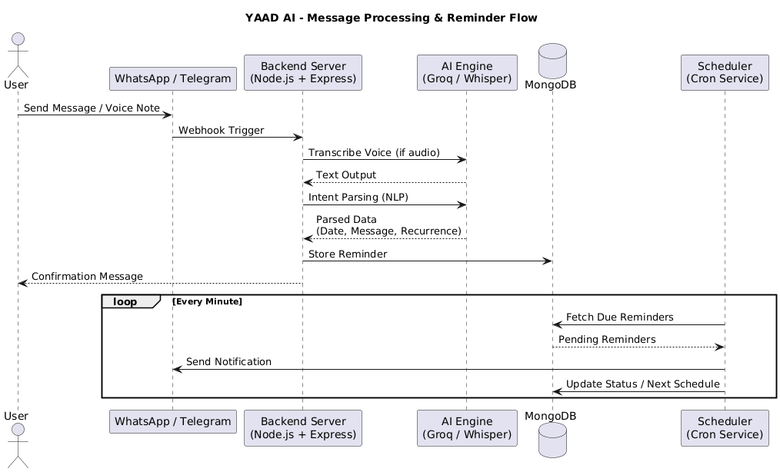

4. High-Level Architecture Components
Component | Responsibility
WhatsApp Business API | Receives and sends user messages and voice notes
Telegram Bot API | Receives and sends user messages and voice notes
Backend Server (Node.js + Express) | Webhook handling, validation, reminder logic
AI Engine (Groq / Whisper) | Speech-to-text and NLP intent parsing
MongoDB | Persistent storage for users, reminders, logs
Scheduler (Cron Service) | Minute-level reminder execution

5. Message Processing Flow
1. User sends a text or voice message.
2. Platform triggers a webhook to backend.
3. Voice messages are transcribed using AI engine.
4. NLP extracts intent, date, time, recurrence.
5. Reminder is stored in MongoDB.
6. Confirmation message is sent to user.

6. Reminder Types (SOW Aligned)
Type | Description | Examples
One-Time | Single execution reminders | Remind me tomorrow at 7 PM
Daily | Repeats every day | Remind me daily at 9 AM
Weekly | Repeats on specific days | Remind me every Monday

7. Timezone & Scheduling
All reminders default to Asia/Kolkata (IST) timezone as defined in the SOW. The scheduler runs every minute to ensure minute-level accuracy. Optional early alerts (e.g., 5 minutes prior) are supported.

8. Voice & Language Support
Feature | Support
Voice Notes | WhatsApp & Telegram
Speech-to-Text | AI-powered transcription
Languages | English, Hindi, Hinglish
Processing | Voice treated same as text after transcription

9. Database Design (MongoDB Schema)
9.1 Users Collection
Field | Type | Description
user_id | String | WhatsApp number or Telegram ID
platform | String | whatsapp / telegram
created_at | Date | Account creation timestamp
free_quota_used | Number | Free reminders used
is_blocked | Boolean | Admin-controlled access flag

9.2 Reminders Collection
Field | Type | Description
reminder_id | ObjectId | Unique reminder identifier
user_id | String | Linked user
message | String | Reminder text
scheduled_time | Date | Execution time (IST)
recurrence | String | none / daily / weekly
status | String | pending / completed
created_at | Date | Creation timestamp
next_run | Date | Next execution for recurring reminders

9.3 Delivery Logs Collection
Field | Type | Description
log_id | ObjectId | Unique log identifier
reminder_id | ObjectId | Associated reminder
attempt_time | Date | Delivery attempt time
status | String | success / failed
error_message | String | Failure reason if any

10. Free Tier & Abuse Prevention
The backend enforces configurable free reminder limits per user. Rate limiting, spam detection, and API throttling are applied. Admins can block users if abuse is detected, fulfilling SOW abuse prevention clauses.

11. Admin Dashboard
Feature | Description
User Count | Total registered users
Reminder Stats | Active, pending, completed reminders
Usage Monitoring | Free-tier usage tracking
User Control | Block / unblock users
System Logs | Basic error and delivery logs

12. Security & Authentication
User identity is bound to WhatsApp numbers or Telegram IDs. No external authentication is required. All secrets are stored securely using environment variables. API keys and webhook endpoints are protected.

13. Deployment & Production Setup
The application is cloud deployed with environment-specific configurations. Background jobs, scheduler, and database are production-ready. Live bot testing and deployment walkthrough are completed as part of delivery.

14. Data Ownership & Confidentiality
All source code and user data belong exclusively to the client. No production data is retained post-handover. The system complies with confidentiality and IP clauses defined in the SOW.
15. Acceptance Criteria
The project is considered complete when WhatsApp and Telegram bots are live, text and voice reminders function correctly, scheduling accuracy is verified, admin dashboard is operational, and free-tier limits are enforced.

